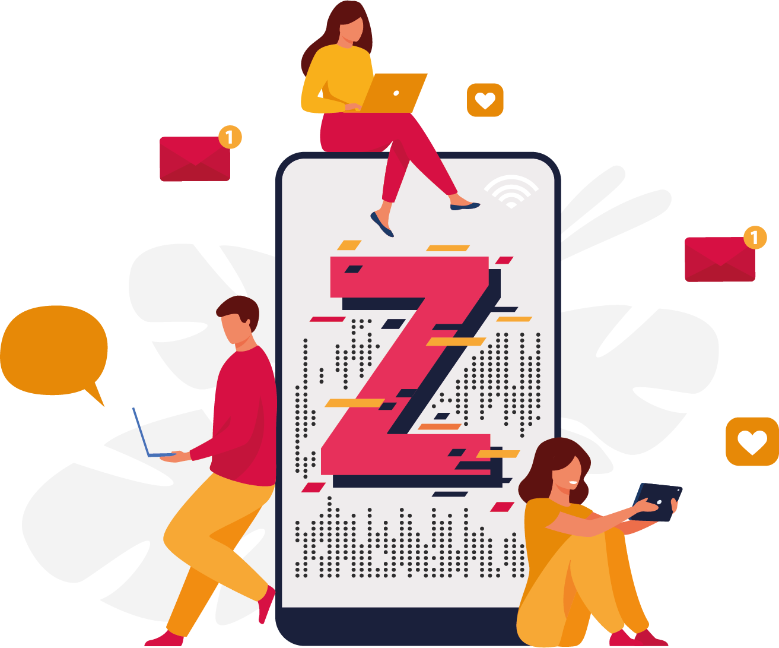

**Problem Statement on Understanding the career aspiration of Gen-Z**

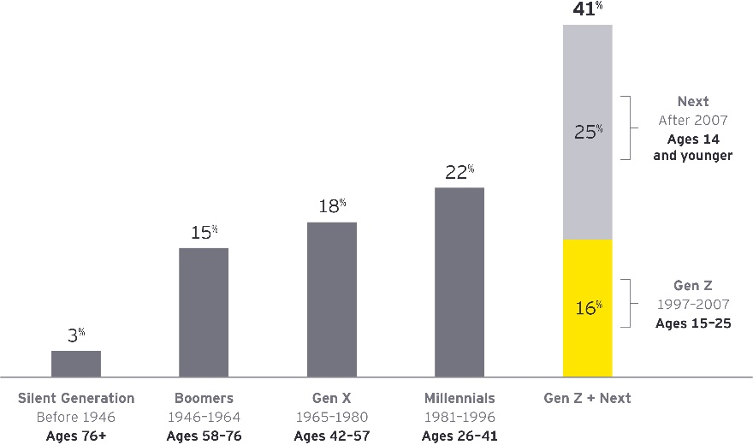**Introduction**

Gen Z also know as Generation Z(those born between 1997 and 2012)

As the first wave of Generation Z enters the workforce during the COVID-19 pandemic, companies are realizing that their current office spaces, operational policies, and company norms may not be as relevant to this emerging employee base as they were to those of decades past. As a result, organizational leaders are striving to better understand the unique needs and desires of this soon-to-be very large and influential demographic group. According to a **2022 Lever report**, 42% of Gen Zers would rather be at a company that gives them a sense of purpose than one that pays more. They’re also more likely than the average person to want to work for a company that takes a stance in addressing important global, societal, and environmental issues.

**Who is impacted by a lack of understanding of the career aspirations of Gen-Z?**

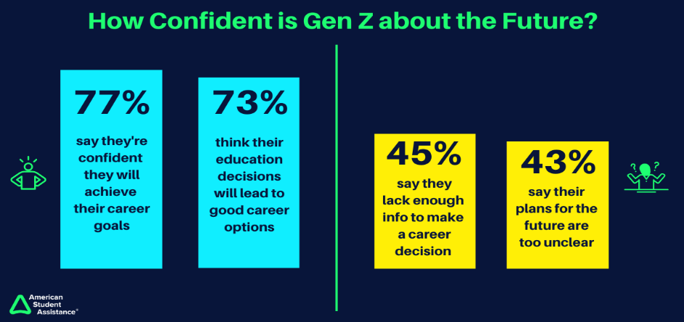Gen Z is the primary group affected by this problem, as they are currently entering the workforce and facing challenges in pursuing their desired career paths. This generation is characterized by their diverse perspectives, digital savviness, and high expectations of work-life balance, workplace culture, and social impact. A lack of understanding of their career aspirations can have an impact on various stakeholders, including the Gen-Z individuals themselves, employers, and the overall workforce. This can result in difficulty for Gen Z in finding meaningful work and reaching their full potential, while employers may face challenges in attracting and retaining talent from this demographic group, leading to skills shortages and reduced competitiveness. Moreover, a lack of contribution from Gen Z could also hinder economic growth and social progress at large.

**What is currently happening with Gen Z?**

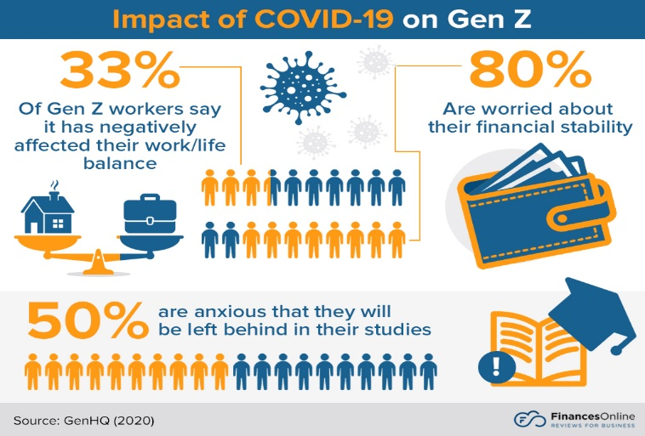Gen Z is finding it hard to get a job because there are many other people competing for the same positions. The COVID-19 pandemic has made things even more difficult by causing many businesses to stop hiring or lay off workers. This means that Gen Z may struggle to find work and may need to adapt to new ways of finding jobs.

If the problem of not understanding Gen Z's career aspirations is not addressed, it could lead to negative consequences such as layoffs. Layoffs happen when a company stops or permanently ends the employment of its workers. This could happen because of business losses, less profit, or when companies merge with other companies and need to reduce their workforce. Hiring new employees from Gen Z could help companies upgrade their skills and make more money. Although it may take some time for Gen Z to fit into a company, once they understand the company values, work culture, and working pattern, they could be a great fit.

Another negative consequence of not investing in employee experience is a lack of skills and customer satisfaction. Employees need the necessary skills to do their job well and should have opportunities to continue to learn and develop. When companies hire new employees from Gen Z, they can focus on investing in tools and technology instead of training. Gen Z employees want to make an impact and work for companies that invest in their talent and treat them fairly.

**When and where is this happing?**

This problem is currently happening globally as Gen Z enters the workforce and navigates the challenges of finding meaningful work that aligns with their career aspirations. The impact of this issue varies by region, with some areas experiencing higher levels of job growth than others. In developed countries, there are fewer job opportunities in industries that traditionally offered secure and well-paid employment. In developing countries, the education and skills of Gen Z do not match the requirements of the labor market, leading to underemployment and job insecurity.

Gen Z is being affected by less technical jobs in the automobile, IT, and corporate world. In the automobile industry, they are unable to clear interview rounds due to a lack of experience. In IT, they lack expertise in specific tools and technology. In the corporate world, employers are looking for candidates with experience and practical understanding of dealing with clients.

Moreover, the tech industry faced mass layoffs in 2022. With reports of a recession in the West, many companies began to lay off employees in order to cut back costs.

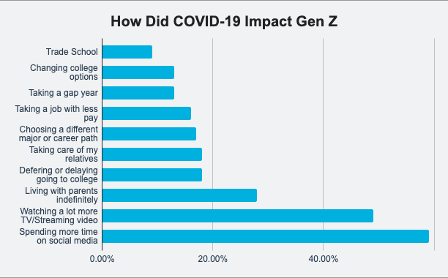If a company believes in Gen-Z and hires them as fresh graduates, they can get the talent which they can use to make some growth, and with that, they are also one of them who need less training to get onboard. If companies start to hire Gen-Z, they can be a great fit for the company and will be able to match their requirements with more profit.

When this is happening. There are many ways in which this happens. It could be the introduction of Chat GPT, which is a new technology, or it can be due to COVID 19, which slowed down every business in that area, or layoffs, which impacted a lot, and scams that are most likely happening.

Gen-Z should develop skills that are complementary to AI, stay informed about technological developments, cultivate relationships and soft skills, embrace technology and automation, be adaptable and flexible, and be open to new opportunities. These skills can help them identify tasks that could be automated or streamlined using technology and explore ways to work collaboratively with machines and AI systems.

**Why is that a problem?**

Gen Z's career aspirations are critical for businesses and economies worldwide, as they represent the future of the workforce. Their inability to pursue their desired career paths can lead to frustration, low motivation, and decreased engagement in the workforce. Additionally, traditional workplaces may struggle to adapt to Gen Z's high expectations of work-life balance and social impact.

Gen Z demands more from their employers due to observing older workers experiencing burnout, time poverty, and economic insecurity. They want bigger paychecks, more time off, flexibility to work remotely, and greater social and environmental responsibility. If their needs aren't met, they are willing to leave.

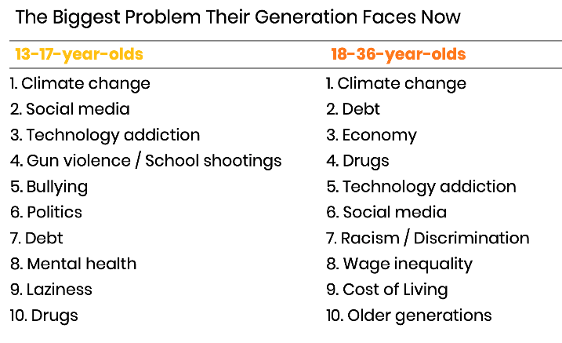Gen Z is the cohort most likely to quit if they're unsatisfied at work. They want companies to follow through on their mission statements, particularly in regard to social and environmental values. Older people care more about personal growth than money, whereas Gen Z thinks of earning more money and getting rich quickly. They often get stuck between societal norms, where 9-to-5 jobs may not be viewed as cool.

To help Gen Z in the workplace, companies should encourage innovation and work-life balance, prioritize mental health, offer flexibility with hours, provide growth opportunities, leverage their desire for change, focus on the individual, be open to learning from them, and establish a safe work culture with aligned expectations. Gen Z does not tolerate toxic cultures, discrimination, misalignment between management's words and actions, or work that doesn't flex to fit their personal lives.

**Objectives of Genz**

The objectives of addressing the career aspirations of Gen Z are to:

Create a more equitable and sustainable workforce that enables individuals to pursue their passions and achieve their full potential.

Foster an inclusive work culture that embraces diversity, equity, and inclusion and accommodates the needs of Gen Z.

Facilitate the development of education and training programs that align with the skills and competencies required by the job market and offer a clear career path.

Encourage entrepreneurship and the creation of new business models that meet the needs of Gen Z and leverage their digital savviness and creativity.

**Conclusion**

The career aspirations of Gen Z are crucial to the future workforce, and addressing their challenges is essential. By creating opportunities for career growth, businesses and economies can ensure they contribute meaningfully. A systemic approach involving stakeholders from different sectors can make work more inclusive, sustainable, and fulfilling for Gen Z. Employers must understand their motives and personality profiles to help them flourish and retain talent from this generation. This is especially relevant as Gen Z enters the workforce and their preferences may evolve in full-time jobs.